Lab – Explore YANG models using the pyang tool

1. Objectives

Part 1: Install the pyang Python module

Part 2: Download YANG models for the IOS XE

Part 3: Use the pyang command line tool to transform the YANG models

1. Background / Scenario

YANG models define the exact structure, data types, syntax and validation rules for the content of messages exchanged between a managed device and another system communicating with the device. Working with files using the YANG language can be a bit overwhelming for the level of details in these files.

In this lab, you will learn how to use the open source pyang tool to transform YANG data models from files using the YANG language, into a much more easily human readable format. Using the “tree” view transformation, you will identify what are the key elements of the ietf-interfaces YANG model.

1. Required Resources

* Access to the Internet
* Python 3.x environment

1. Install the pyang Python module

In this part, you will install pyang module into your Python environment. Pyang is a python module that simplifies working with YANG files. The Pyang Python module comes with a pyang command line executable that transforms YANG files into a more human readable format (tree, html, etc.).

1. Use pip to install pyang.
   * + 1. Start a new Windows command prompt (cmd).
       2. Install pyang using pip in the Windows command prompt:  
            
          pip install --no-binary pyang pyang

NOTE: on mac or linux you can simply “pip install pyang” but temporarily on Windows the binary WHL file won’t include the Windows executable pyang file.

* + - 1. Verify that pyang has been successfully installed. In the command prompt, type:

pyang -v

to display the installed pyang version:

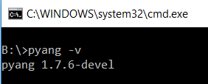

1. Download YANG models for the IOS XE
   * 1. Explore YANG models on the YangModels/yang GitHub repository.
        1. Using a web browser, navigate to <https://github.com/YangModels/yang>:
        2. Navigate to the vendor -> cisco -> xe -> 1661 directory. This directory represents all the YANG models that are supported in Cisco operating system IOS XE in version 16.6.1.
        3. Explore the ietf-interfaces.yang model.
     2. Download the YANG models for the IOS XE VM
        1. Unpack the YANG models from the official GitHub repo for cisco-xe-1661.zip archive file that contains a snapshot of the files in the GitHub repository.
2. Use the pyang command line tool to transform the YANG models
   * + 1. Start a Windows command prompt and navigate to the directory with the extracted archive file.
       2. Use the pyang tool to transform YANG files to a human readable format, for example using the “tree” format transformation:

pyang -f tree ietf-interfaces.yang

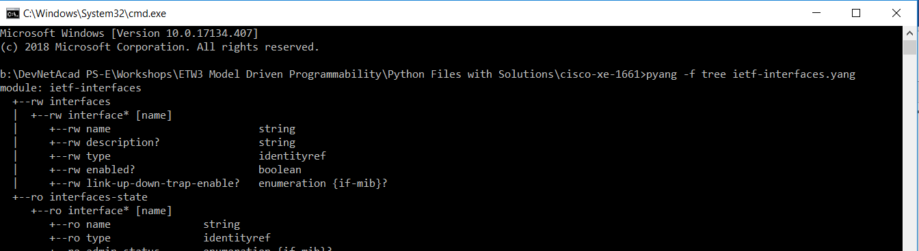

* + - 1. Explore other YANG modules, for example the Cisco Native model for CDP: Cisco-IOS-XE-cdp.yang
      2. Are there any “read only” operation data in the Cisco-IOS-XE-cdp.yang model? Answer the question.
      3. Is there any other YANG model that includes operational CDP data? Answer the question.